**Ex. No.: 11b)**

**Date: 09-04-2025**

**LRU**

**Aim:**

To write a c program to implement LRU page replacement algorithm.

**Algorithm:**

1: Start the process

2: Declare the size

3: Get the number of pages to be inserted

4: Get the value

5: Declare counter and stack

6: Select the least recently used page by counter value 7: Stack them according the selection.

8: Display the values

9: Stop the process

**Program Code:** #include <stdio.h> int findLRU(int time[], int n) { int i, min = time[0], pos = 0; for (i = 1; i < n; ++i) { if (time[i] < min) { min = time[i]; pos = i;

}

}

return pos;

} int main() { int frames[10], pages[30], counter[10]; int i, j, k, pos, max, faults = 0, time = 0; int n, f; printf("Enter number of frames: "); scanf("%d", &f); printf("Enter number of pages: "); scanf("%d", &n);

printf("Enter reference string: "); for (i = 0; i < n; ++i) scanf("%d", &pages[i]); for (i = 0; i < f; ++i) {

frames[i] = -1; counter[i] = 0;

}

printf("\n"); for (i = 0; i < n; ++i) { int flag1 = 0, flag2 = 0; for (j = 0; j < f; ++j) { if (frames[j] == pages[i]) { time++; counter[j] = time; // Update recent use time flag1 = flag2 = 1; break;

}

}

if (flag1 == 0) {

for (j = 0; j < f; ++j) { if (frames[j] == -1) { time++; faults++; frames[j] = pages[i]; counter[j] = time; flag2 = 1; break;

}

}

}

if (flag2 == 0) { pos = findLRU(counter, f); time++; faults++; frames[pos] = pages[i]; counter[pos] = time;

}

// Display current frame state for (k = 0; k < f; ++k) { if (frames[k] != -1) printf("%d ", frames[k]); else printf("-1 ");

}

printf("\n");

}

printf("\nTotal Page Faults = %d\n", faults);

return 0;

}

**OUTPUT:**

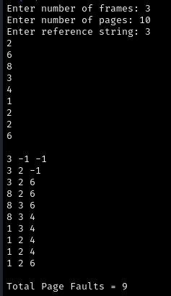

**RESULT:**

Hence, page faults that occur using LRU page replacement technique has been found.